PRODUCT GENERAL DESCRIPTION
Synthetic description of the product: In 1985, Professor Galinski discovered in the Egyptian desert that desert halophiles produce a natural protective component, Ectoin, in the outer layer of cells under high temperature, dryness, strong UV irradiation and high salinity, thus activating the self-repair function. In addition to deserts, the fungus is also found in saline lands, salt lakes and seawater. In extreme conditions of high salt, high temperature and high UV radiation, Ectoin protects halophiles from damage. One of the reasons why Ectoin allows halophiles to survive in extreme conditions is that they can regulate osmotic pressure. It is a very strong hydrophilic substance, and although it has a small molecular weight, it forms a "hydration shell" around cells and proteins, by binding to water molecules in the surrounding environment, similar to a stable protective film, to reduce water loss from the skin. Studies have shown that Ectoin has a very good restorative and protective effect on the skin, and is one of the bioengineered agents used in high-grade cosmetics.
Product Name:Ectoin | 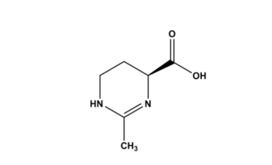  Structural formula
Synonyms: 4-Pyrimidinecarboxylicacid
chemical name: 2-Methyl-1,4,5,6,-tetrahydro-pyrimidine-4-carboxylic acid
CAS: 96702-03-3
Molecular Formula: C₆H₁₀N₂O₂
Molecular Weight: 142.16

PRODUCT SPECIFICATIONS || DATA PROCESS SUMMARY

Appearance | White powder | drying shrinkage
Assay |  | Water
impurity
heavy metal
Residue on ignition
Content

MAIN RAW MATERIAL for FERMENTATION || MAIN RAW MATERIAL for RECOVERY

quality standard |  | packing specification
product certification |  | Outside the bag material
quality guarantee period |  | Other

DSP – BLOCK DIAGRAM

