PRODUCT GENERAL DESCRIPTION
Synthetic description of the product: Hydroxytyrosol is a natural polyphenolic compound with strong antioxidant activity, mainly in the form of esters found in the fruit and branches of olives, with a variety of biological and pharmacological activities, which can be derived from olive oil and wastewater generated from the processing of olive oil. Hydroxytyrosol is a component of the olive that acts as a highly active antioxidant in the body. As biologically active molecules, antioxidants are present in many plants, but with different activities. Hydroxytyrosol is considered to be one of the best antioxidants and its commercial value is on the rise. Studies on natural hydroxytyrosol have found that it has the ability to penetrate the blood-brain barrier and is absorbed in the gut. Its antioxidant properties are similar to those of green tea and grape seed extracts. Studies have also found that this chemical is second only to garlic in its ability to protect cellular health, and it has been shown to treat colon and breast cancer, as well as lower cholesterol levels and treat degenerative diseases such as Alzheimer.
Product Name: Hydroxytyrosol | 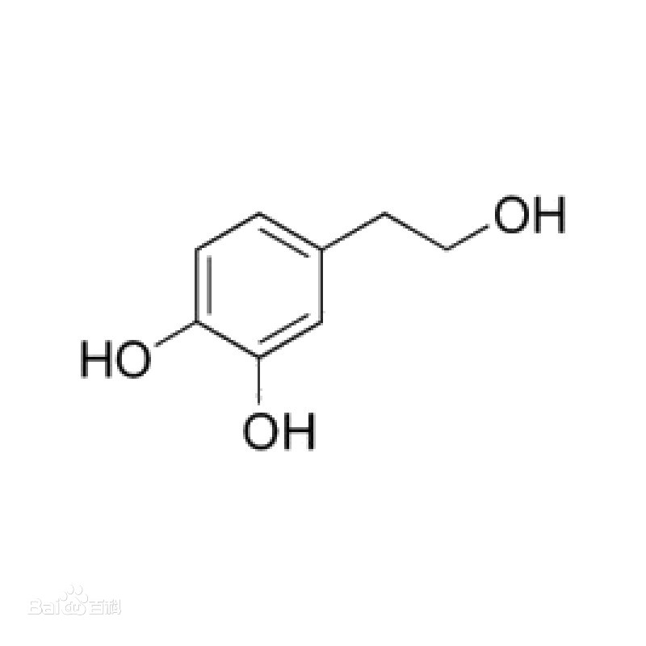  Structural formula
Synonyms: 3,4-Dihydroxyphenylethanol
chemical name: 3,4-Dihydroxyphenylethanol
CAS: 10597-60-1
Molecular Formula: C₈H₁₀O₃
Molecular Weight: 154.16

PRODUCT SPECIFICATIONS || DATA PROCESS SUMMARY

Appearance |  | drying shrinkage
Assay |  | Water
impurity
heavy metal
Residue on ignition
Content

MAIN RAW MATERIAL for FERMENTATION || MAIN RAW MATERIAL for RECOVERY

quality standard |  | packing specification
product certification |  | Outside the bag material
quality guarantee period |  | Other

DSP – BLOCK DIAGRAM

